Switchvox Compatibility with MS Office 365

Switchvox Is Compatible with MS Office 365
But it requires some additional setup to be usable.
Option 1: You will be required to setup a SMTP account on your Switchvox in order to relay messages from your switchvox to your office 365 Server
Note: if you don't have a Username, Password and SMTP server configured on your PBX. Switchvox will send email using its own SMTP server. Some email servers can accept emails from private SMTP servers other will reject them. Office 365 falls in the category that rejects email when Switchvox sends by itself.

Steps
- Create an email account for relay purposes on your Office 365 server (See How to set up a multifunction device or application to send email using Office 365 , then you would use option 1 )
- Go to: Tools > STMP Settings
  - Email "From Address": <email that you would like to see when the PBX sends notifications>
  - Outbound SMTP server: smtp.office365.com
  - Outbound SMTP Username: <Email that you created on your Office 365 for relay purposes >
  - Outbound SMTP Password: < Password of the email that you created for relay purposes>
  - Outbound SMTP Port: 587
  - Connection Encryption: STARTTLS
If you are Digium Cloud User, you will need to contact Digium Tech Support to change the SMTP configuration, please make sure to have the Username and Password ready.

Option 2: Change your exchange configuration
- Log into your system
- Exchange Admin Center > Protection
- Connection filtering > Default
  - Whitelist IP <Your Switchvox IP>
  - Enable Safelist
  - Enable Spam Filter > Default

Step 1
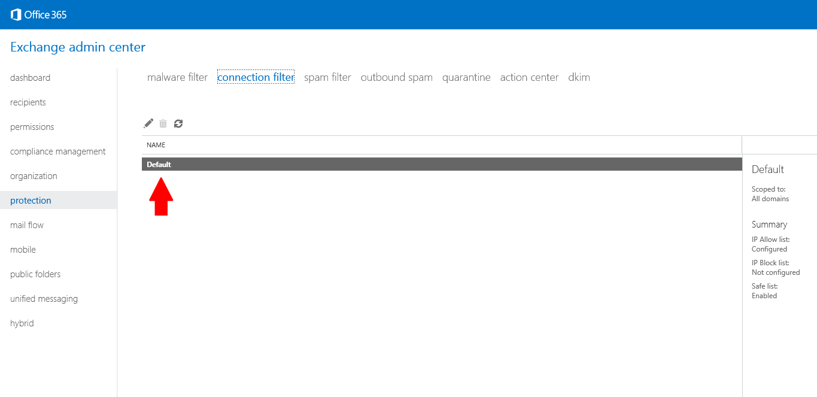

Step 2
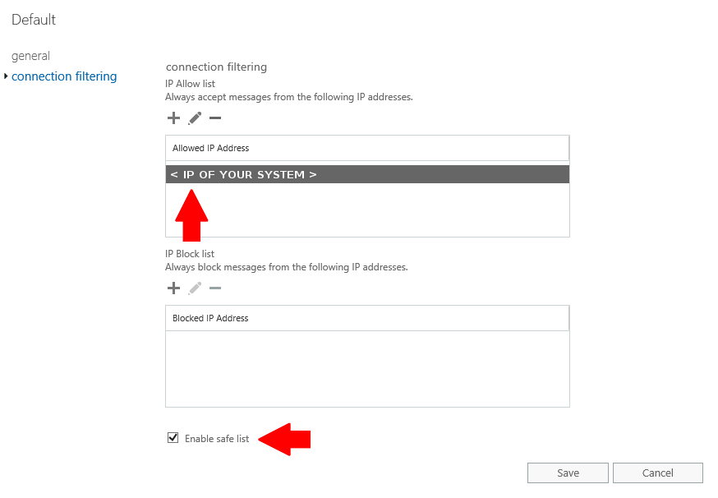

Step 3
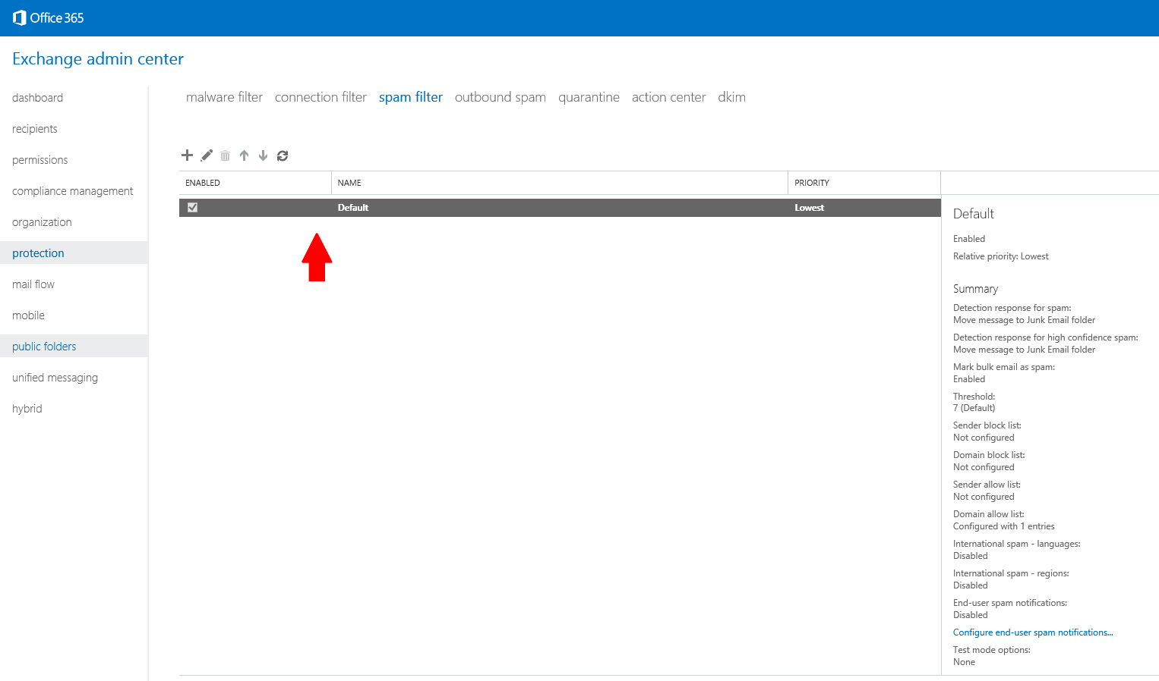
Step 4 - Add the FULL URL of the customer's cloud server (for example: xxxxxxx.digiumcloud.net)
